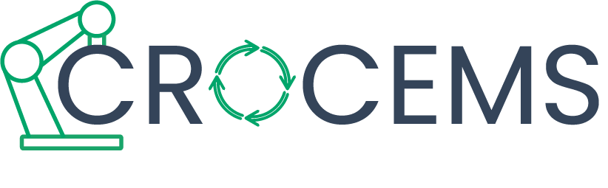

**COLLABORATIVE ROBOTICS FOR CIRCULAR**

**ECONOMY IN MANUFACTURING SECTORS**

**[2021-1-ES01-KA220-VET-000034799]**

Memorandum of Understanding

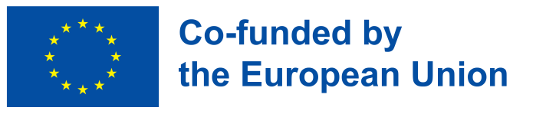

Funded by the European Union. Views and opinions expressed are however those of the author(s) only and do not necessarily reflect those of the European Union or the European Education and Culture Executive Agency (EACEA). Neither the European Union nor EACEA can be held responsible for them

# CROCEMS MEMORANDUM OF UNDERSTANDING

**Date:**

**Location:**

**CONTEXT**

The Public Launch of the CROCEMS Blueprint represents a pivotal moment in advancing lifelong learning and skill development, with a particular focus on applying collaborative robotics to Circular Economy processes in manufacturing sectors. This event brings together representatives from diverse fields to solidify their shared commitment to fostering innovative training and promoting adult education, especially among enterprises and individuals engaged in the manufacturing and Circular Economy sectors.

The memorandum underscores a collective commitment from organizations across Europe—spanning academia, industry, government, and civil society—to support the objectives, outcomes, and actions of the CROCEMS Blueprint. Its aim is to drive forward the integration of collaborative robotics and Circular Economy principles into skills development and training programs.

Beyond its symbolic importance, the signing of the Memorandum serves as a dynamic outreach effort to spotlight the transformative impact of CROCEMS. It seeks to inspire participation from educational leaders, policymakers, and industry innovators eager to expand access to lifelong learning and equip participants with the tools needed to excel in Circular Economy practices.

CROCEMS project leaders warmly welcome attendees, creating an opportunity for dialogue and collaboration. This launch lays the groundwork for future initiatives that further enhance partnerships and reinforce the role of collaborative robotics in fostering a sustainable manufacturing sector.

**MEMORANDUM OF UNDERSTANGING**

**Name and Surname:**

**Position:**

**Organisation_**

**Address:**

**City, Postal Code:**

I, the undersigned, NAME AND SURNAME , in my capacity as POSITION, express our support to the CROCEMS project (project number: 2021-1-ES01-KA220-VET-000034799) and its mission to fill a gap in Vocational Education and Training and create a new course focusing on the introduction of Circular Economy in manufacturing sectors by using collaborative robotics to perform waste management.

Our organisation is looking forward to collaborating with the CROCEMS Consortium to ensure that the project's materials not only reach and benefit VET learners in our community, but also contribute to promoting CROCEMS' core values, such as promoting lifelong learning among VET students and companies.

By supporting this initiative, we aim to give VET students and companies the skills and opportunities they need to succeed, while actively upholding the project's mission of inclusion, adaptability and lifelong learning in action.

Finally, CROCEMS developed a blueprint that identifies five priorities and related actions for stakeholders. We agree with the five priorities: inform, fund, guide, connect and train. For each priority, a set of recommendations is detailed in the Blueprint Document, available here <https://crocems.eu/project/#blueprint>

**With this declaration, we commit to using the levers at our disposal coherently to support the priorities of the CROCEMS blueprint**

**for introducing Circular Economy in manufacturing sectors by using collaborative robotics to perform waste management.**

**Name of the signatory**

**Position of the signatory**

**Signatory**